PM and states at odds as report calls for cooperation on population growth
Infrastructure Australia’s call for partnership seems likely to fall on deaf ears at governments’ meeting
Katharine Murphy and Gareth Hutchens
Tue 11 Dec 2018 08.35 AEDT Last modified on Tue 11 Dec 2018 09.41 AEDT

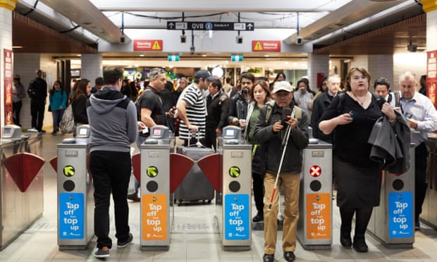
Commuters at Sydney’s Town Hall station. A new report from Infrastructure Australia does not recommend
cutting immigration as a response to population pressures. Photograph: Erik Anderson/AAP
Australia needs a new partnership between all tiers of government to plan for population growth, with our largest cities currently growing at a rate not seen for more than 50 years, according to Infrastructure Australia.
The call from the independent statutory body responsible for prioritising and rolling out nationally significant infrastructure comes ahead of Wednesday’s Coag meeting between Scott Morrison and the premiers, which will see tensions over population policy and Morrison’s proposal to slow the rate of immigration.
While Morrison wants Wednesday’s conversation to be about landing on a more collaborative process between Canberra and the states for setting migration levels, the Labor jurisdictions will ensure the population debate is tied to a broader discussion about sustainable commonwealth funding for health, education, early childhood and infrastructure.
Ahead of Wednesday’s meeting – Morrison’s first as prime minister – only one premier, Gladys Berejiklian, has thus far echoed his call for cutting immigration.
The new report from Infrastructure Australia – which is the third public appeal the body has made for a more coherent approach to planning over the past couple of years – recommends the commonwealth “lead development of a common vision and evidence base, in partnership with state, territory, and local governments, industry, and the community, to better strategically plan for our future population”.
As well as recommending a more collaborative process, it also advocates a root-and-branch review of funding for local infrastructure, including examining mechanisms like value capture and levies to fund projects.
It does not recommend cutting immigration as a response to the current pressures.
The report notes that Australia’s population is projected to increase by more than 11 million between 2017 and 2047, with 80% of the growth expected in Australia’s five largest cities – Sydney, Melbourne, Brisbane, Perth and Adelaide.
It says the growth in cities will be accompanied by major societal and demographic shifts “such as the changing nature and location of work, the ageing of the population, rapid technological transformation, an increasing urban freight task, and climate change”.
“More than ever before, Australia’s long-term prosperity is linked to the performance of our cities,” it says.

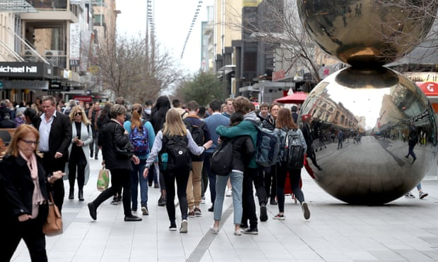

Facebook Twitter Pinterest
Pedestrians in Rundle Mall in Adelaide – one of the cities where the population is set to increase dramatically. Photograph: Kelly Barnes/AAP
It notes that a lack of a coordinated approach to population planning and infrastructure development has contributed to declining trust in the capacity of governments to deliver services.
It says lags in infrastructure provision has reduced the liveability of communities. “In inner areas, this can often translate into over-enrolment in schools, increased congestion on roads, overcrowding on trains and buses and competition for space at parks.
“In greenfield areas, this can mean public transport networks or local community services are not delivered until well after new residents move in and patterns of behaviour, such as car use, have become well entrenched.”
Morrison flagged in mid-November that he would use this week’s Coag meeting in Adelaide to talk about population policy and ensure that migration levels aligned with the “carrying capacity” in large cities including Sydney and Melbourne, and later in the month, he flagged cutting the migration rate.
According to Wednesday’s Coag agenda obtained by Guardian Australia, population planning and management is number one on the agenda for the meeting, followed by drought and small business payment terms.
The leaders will discuss a range of social reforms, including reducing violence against women, early childhood education, bullying and health, and well as a refresh of the Closing the Gap program. The New South Wales government has also added an agenda item listed as “dynamic federalism”.
In the afternoon, leaders will discuss a range of national security issues, including safeguarding democratic processes, which is an agenda item about ensuring that elections are free from interference – and strengthening responses to cyber incidents.
There will be a discussion about the capability of agencies to deal with terrorist threats, organised crime and child exploitation, and there is an agenda item about increasing collaboration on national security threats.
Victoria’s premier, Daniel Andrews, will not be coming to Coag with a concrete proposal on population and migration. In recent days Andrews has said it is impossible to have a serious conversation about population – including levers to control migration levels – without also talking about funding for infrastructure, hospitals and schools in different parts of the country.
Victoria has 25% of Australia’s population and it receives 10% of the commonwealth’s infrastructure funding.
The Queensland premier, Annastacia Palaszczuk, has a similar attitude. She will not have a specific proposal for the population question, but she will have questions about Queensland’s share of infrastructure funding.
Queensland wants more help from the federal government for major infrastructure projects, like Brisbane’s $5bn cross-river rail project. It is jealous of the billions of dollars in funding going to NSW and Victoria. It sees infrastructure through the lens of equity – given the geographic size of Queensland, its population needs quality infrastructure covering vast distances.
Palaszczuk will also have questions about climate change particularly in relation to droughts, and recent devastating fires in the state, and the problem of cyberbullying.
The Western Australia premier, Mark McGowan, will not be raising specific proposals on migration.
Andrew Barr, the chief minister of the Australian Capital Territory, thinks any discussion of migration needs to consider infrastructure. “The ACT welcomes a discussion on how states and territories can become more involved in migration policy,” a spokeswoman for the chief minister said.
“However, this is also a conversation about infrastructure requirements and the federal government must play a role in supporting infrastructure investment in this country.”

